MKT3033 E-Marketing Strategy and Social Media
Assignment 2 Group Work
By

Table of Contents
1 Executive Summary 3
2 Situation Analysis / Background 3
2.1 Industry/Market Review and Analysis 4
Key Competitors 7
3 - Goals, Objectives and Measurement Strategy 26
SMART Goal and Objectives 26
Measurement Strategic Plan 27
All Professional Services 30
Done In-house 31
References 33

1 Executive Summary
Namshi is a reknowned corporation in the ecommmers industry , it is famouse and known to be the shopping place in the middle east industry .During the 3 years of operating since 2001 , it has stood out and positioned it self to be strong in the market.The demand fo online shopping has increased massively. Hence why Namshi has achived a strong position in the middle east.
The Search Engine Optimization is a vital Acquisition strategy that Namshi applies effectively. But Namshi can decrease the cost of advertisement by removing the Paid Search link on Google. Another recommendation-for-Namsh-to-continue-being-a-successful-online-shopping-site-is by changing/adding-some-elements in-the-retention-strategies-that-it applies. Some minor change- to-the-Website,-Emails-and-Twitter-account-would-increase-the-effectiveness-of-such-elements. This report is an analysis that included the Company’s Background, Business Model, Target Market, Acquisition and Retention Strategies with Commendations and Recommendations

2 Situation Analysis / Background
Namshi is an online retailer that was founded in the GCC that sell a wide range of clothing apparel with the use of E- commerce. Their products include clothing, accessories, shoes and bags. They sell numerous big brand names, which include, Nike, Lacoste, Timberland, Guess and many more.
Namshi have social presence on a number of social media platforms, which include, Instagram, Facebook, Pinterest, twitter as well as YouTube. There large presence has allowed them to have great exposure across the Gulf countries as 75% of Middle Eastern consumers have a strong belief that their interactions on social media with brands will lead to them to higher purchases.
URLS:
- Website: https://en-ae.namshi.com/
- Instagram: https://www.instagram.com/namshi/
- Facebook: https://www.facebook.com/NamshiFans
- Twitter: https://twitter.com/NamshiDotCom
- Pinterest: https://www.pinterest.com/namshidotcom/
- YouTube: https://www.youtube.com/user/namshidotcom?sub_confirmation=1
Namshi also have their own journal/blog:
- https://journal.namshi.com/

2.1 Industry/Market Review and Analysis

2.1.1 Industry/Market

In the past few years E-commerce has grown significantly. The idea of online buying first came around in the 1970’s and has changed the way people buy products and services. The industry has allowed millions of business to offer their products/services to consumers with the use of online platforms such as websites and social media. This is due to increased technological advancements as well as great popularity of social media platforms across the globe.

Sales and Growth Rates
Figure 1
The number of sales globally in past three years (2013-2017) is $2.35 Trillion, which is an increase of 88%from 2013. This increase has shown the popularity of E-commerce selling and seems to be a viable strategy that most online businesses such as Namshi are perusing.
MENA (Middle eastern North African) market has shown the most growth in the industry over the past decade. This is largly Due to the fact that there is an increase of disposable income in these countries. According to the World Bank (2017) the GNI (Growth National Income) in the MENA region is $8,234 per capita, while the GDP for this region is $3.1 trillion.
The GCC region has the highest GDP compared to the rest of the Middle East. The GCC compromises of six countries: Bahrain, Kuwait, Oman, Qatar, Saudi Arabia, and United Arab Emirates. The high standards of living and income levels means that business in these countries usually does well, however the increased competition means that it can be very hard for a business to penetrate the market and be successful.

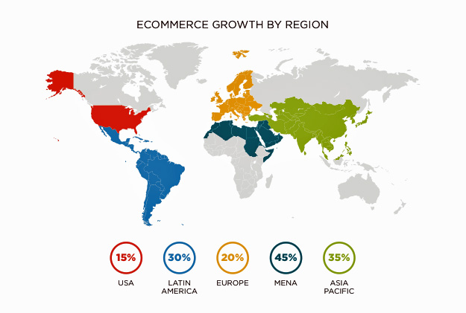

Key Competitors
(Keyword Research, Competitor Analysis, & Website Ranking | Alexa, 2017)
(Website Worth & Domain Value Calculator - Buy & Sell Websites/Domains, 2017)

 | Global Rank | Daily Unique Visits | Daily Page views | Bounce rate | Daily time on site | Search engine traffic
Namshi | 12,912 | 43,100 | 290,494 | 35.20% | 7:05 | 23%
Souq | 570 | 770,000 | 3,865,400 | 42.20% | 6:70 | 11.40%
MARKAVIP | 64,659 | 6,550 | 22,925 | 48.30% | 4:16 | 13.50%
SIVVI | 65,631 | 6,200 | 25,172 | 42.70% | 4:32 | 13.40%

All 4 websites are leading in the e-commerce industry when it comes to the MENA region. Souq.com is the only one of them adopts the amazon mentality which is using sellers, but for the other 3 all products are strictly sold by the website itself. Souq.com is also the only website that sells a variety of other products but Namshi, MarkaVIP and SIVVI are fashion focused

Souq.com
URL | Website Observation | Social Media Activity | Key Words Used | Content Strategy
http://uae.souq.com/ae-en/ | - Too congested with various products and deals  - Social Plugins  - Email subscription/  Registration | - Active on YouTube with Ads & 96k subscribers.  - 8,326,152 Facebook likes  - 32.8K Instagram followers  - 43.2 Twitter followers  - Consistent with updates and content. | - Shop now  - Best deals, everyday  - Recommended for you  - Trending now  - Sell with us | - Attractive content of products and special offers  - Variety of product options  - Gift idea suggestions for every occasions
Strengths |  | Weaknesses
- 100% Guarantee of seller and buyer protection  - Various convenient payment methods (debit/visa card, cash on delivery)  - YouTube channel available bringing their products to live with reviews and etc.  - Wide range of products available (clothing, electronics, toiletry, groceries) |  | - Site containing various advertisements which may despite the user needs  - Same day shipping unavailable  - Individual sellers so quality or originality is not guaranteed
Gap Analysis
Although Souq guarantees 100% protection in both buyers and sellers end, it highly lacks guarantee of the products quality and originality, which does not fit into buyer’s protection. Therefor Souq does not meet their objective of gaining loyal customers.
Their strategy of meeting different customers needs via ecommerce have made their website overly congested with a lot of things and offers going on in the same time which can confuse the customers.

MARKA VIP

URL | Website Observation | Social Media Activity | Key Words Used | Content Strategy
https://markavip.com/en-ae | - Prominent search box  - Social Plugins  - Special deals tab  - Clean and simple navigational tool  - Featured products images and description  - Related products visibility | - Not consistent on social media channels  - 1,543,684 Facebook likes  - 88.9k Instagram followers  - 60.9k twitter followers | - Express delivery  - Subscribe  - 100% secured website  - Hottest brands | - Special deals oriented  - Well customization of preferred categories  - Inspirational looks available for sale  - Clear description of products.  - Qualitative photos.
Strengths |  | Weaknesses
- Authentic products guaranteed in great prices  - Customer service available  - 100% secured website regards with information and payment  - User friendly website and mobile app |  | - Shipment takes longer then promised, up to 30 days  - Search engine unpredictability
Gap Analysis
MARKA VIP ‘s keyword strategy into getting into consumers mind is poor, they don’t have strong keywords, which deeply engage with the customers and results them into call into action. As well as their consistency on social media is very poor, they should be overly active and keep their viewers up to date with their offers and products since this world practically operates through our social media.

SIVVI

URL | Website Observation | Social Media Activity | Key Words Used | Content Strategy
http://en-ae.sivvi.com/ | - Compatible with Smart phones, tablets and desktop  - Smooth browsing experience  - Appealing layout & color scheme  - Slide show of images/products  - Social plugins  - Register and login feature | - Consumer engagement through brand ambassadors  - Active on Snap chat  - 618 Twitter followers  - 33.8k Instagram followers  - 84.5k Facebook likes | - Shop Now  - Fashion  - Free delivery  - Cash on delivery  - Full refunds  - Sign up  - 10% discount on first order | - Products well presented in slideshow format  - Inspired looks by stylist available  - Customer convenience in regard of shipping and payment
Strengths |  | Weaknesses
- Top desired brands available  - 10% discount given on the very first order  - No charge delivery within UAE  - Strong marketing on social media with the use of brand ambassadors |  | - Not a user friendly website, has inconvenient tab pop up  - Customer service on the dial unavailable therefor it takes some time for customers to get assisted.
Gap Analysis
SIVVI has a low SEO ranking due to recent entry in the ecommerce market although their keyword strategy is fairly strong and they are steadily growing In the social media networks. The strategy of marketing through brand ambassadors who are highly influenced online is a great approach in gaining the visibility in various search engines but they have to be consistent with their content to keep it up and going.

Target Market
When a company has a product to sell, understanding their target market plays a vital role in whether the business will fail or not. Identifying the target audience allows a company to have effective marketing communication strategies. Eliminating unnecessary groups of individuals allows a company focus on potential customers and reach the right audience, while being cost effective at the same time. Namshi does not focus on a specific gender when targeting their audience; their wide choice of clothing and apparel fit the criteria of Men and Women, as well as kids. As part of their demographic segmentation, some age groups are more targeted that others. As per their website, their portfolio of kids wear range from new born babies to teens of the age of 16 (Namshi, 2017)

Demographic

Generally, the age group of the men and women are not specified. However, because of the characteristics and different styles Namshi offer, most customers fall under the category as “Generation Y”. This segment of people was born in the 1980’s and early 1990’s, they buy and select products to define their personalities; thus, they are very fashion forward and like to keep up to date with trends (Jensen and Hansen, 2010) this demographic age ranges from 20-35. In terms of the behavioural segment, Generation Y, are the most brand loyal consumer base.

Geographic

According to their Frequently Asked Questions (Namshi, 2017), Namshi do not offer their services internationally. As stated on their website, their current geographic market includes the GCC regions and Jordan. Namshi have chosen this region because of the high buying power of the people. Over the past 15 years the Gross National Income per capita in the targeted market have grown significantly. Data shown below are is the GNI per capita in the GCC region (World Bank, 2017).

Fig. 3

Since the income levels in this region are relatively high, the purchasing power is also high. Women have more disposable income than men, with women in the UAE having the highest percent than other GCC countries (Maceda, 2014). Namshi made the right decision by entering this region as profit potential vast.

2.2 Overview of your business
As the e-commerce market is rapidly growing, the competition within the market is growing rapidly as well; only the best and most relevant are able to survive and conquer market shares.
The following section is an analysis of Namshi’s online presence across multiple platforms; followed by a SEO strategy in an attempt of bettering the search result ranks of the website and finally a set of recommendations about handling the social media of Namshi and building a better customer involvement as well as loyalty.

Namshi

URL |  | Website Observation | Social Media Activity |  | Key Words Used | Content Strategy
https://en-ae.namshi.com/ | - A lot of options and information on one page  - Visibility of top rated brands  - Social plugins |  |  | - 781k+ Facebook likes  - 336K Instagram followers  - 326 Twitter followers  - Inconsistent with Content  - Minimal activity on pinterest. | - Free delivery  - Free exchange  - Cash on delivery  - No1 fashion destination in the middle east  - #mynamshi | - Video Ads of their latest collection on their homepage  - Connecting through majority of the social networks  - Flexibility of return policy and payment method, building trust
Strengths |  |  | Weaknesses
- Convenient & trustworthy payment methods  - Next day delivery  - 14-day exchange policy.  - Namshi Journal which provides reviews and style recommendations  - YouTube channel available with their latest launches and behind the website (office) fun.  - Top rated and qualitative brands available. |  |  | - Immediate contact unavailable  - Not major price difference then the stores  - Customer review on individual product is unavailable
Gap Analysis
Namshi is the leading fashion destination in middle east and has a high SEO ranking although there are some things that Namshi is lacking off. Since ecommerce doesn’t give a chance of face-to-face experience between the seller and buyer, they also don’t have the option of immediate assistant within the website and their customer service.

Namshi has the potential to become “the leading fashion destination in the middle east” as the claim, but they need to pay more attention towards customer engagement. Online assistance and quick feedback is also lacking.
Search engine optimization (S.E.O).

Search engines are very important when it comes to e-commerce as they are the first organic lead towards a website site and usually directs the highest amount of traffic. After examining Google search using key words such as online shopping and online clothes shopping; Namshi does show on the first page but is at the third place.

Fig.4 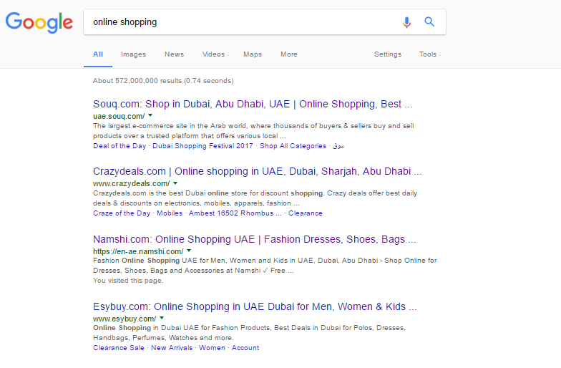

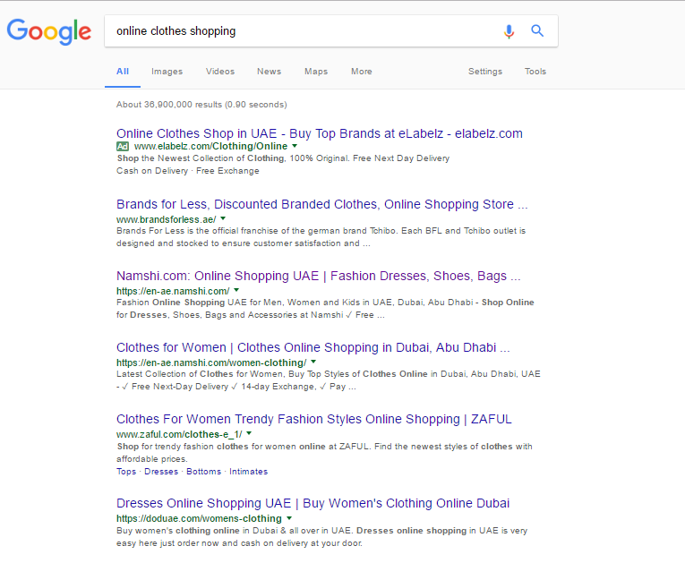
Fig.5

Topic | Current | Improvements
Most Common  Keywords Test |  Search engine algorithms have evolved beyond keyword density metrics as a significant ranking factor   namshi - 2 times   arabia - 2 times   bahrain - 2 times   oman - 2 times   jordan - 2 times |  It can be useful, to note which keywords appear most often on your page and if they reflect the intended topic of your page.  More importantly, the keywords on your page should appear within natural sounding and grammatically correct copy.  Suggested keywords :  Online Shopping, Shop, Shopping
Keyword Usage |  Your most common keywords are not appearing in one or more of the meta-tags above.  Your primary keywords should appear in your meta-tags to help identify the topic of your webpage to search engines. | First of all, you must make sure that your page is using the title and meta-description tags.  Second, you must adjust these tags content in order to include some of the primary keywords displayed above.
<h1> Headings  Status |  The home page does not contain any H1 headings. H1 headings help indicate the important topics of your page to search engines. While less important than good meta-titles and descriptions, H1 headings may still help define the topic of your page to search engines. | Iinsert “Namshi Online Shopping” between <h1>...</h1> tags.
<h2> Headings  Status |  The home page does not contain any H2 headings. H2 headings help describe the sub-topics of your webpage to search engines. While less important than good meta-titles and descriptions, H2 headings may still help define the topics of your page to search engines. | Insert “500+ Brands or Shop online” those sub-topics between <h2>...</h2> tags.
Site map |  The site lacks a sitemap file. Sitemaps can help robots index your content more thoroughly and quickly. | Create a sitemap.xml file for the website.
Broken Links  Test |  Analyzed 14 links on your page - 2 of them appear to be broken. Broken links are listed below:   https://ar-jordan.namshi.com/   https://en-jordan.namshi.com/ | identify within your page all the reported broken links and replace the content of the attribute with a proper URL.
Social Media Check |  website is not connected with social media using the API's provided by Facebook, Google +, Twitter, Pinterest etc. | Connect the website with at least one major social network. To do that, you must insert into your page some social networks plugins: Facebook Like Button, Facebook Share Button, Facebook Comments, Twitter Button, Google +1 Button, Pinterest Button

(Free Website Analysis Report | SEO.com, 2017)
Due to the lack of face-to-face engagement of e-commerce, the only way to engage with customer is to be active on all social media platforms in an engaging creative way without giving impression of being desperate or needy.
Platform | Purposed content | Objective | Frequency
Facebook  @NamshiFans | - + 781K likes on their verified official Facebook page.  - Facebook statuses featuring photos, blogs post and articles surrounding new collections and other brand related updates. | - Increasing brand awareness  - Increase website traffic  - Increase customer interactions  - Increase sales | 1-2 daily posts
Instagram  @Namshi | - Visually pleasing photos about new arrivals, sales and collaborations  - Instagram story Collaborations | - |Increase brand awareness  - Increase website traffic  - Increase sales | 1-2 posts daily
Twitter  @NamshiDotCom | - Tweets & photos about new arrivals, sales and collaborations  - Tweets about relevant topics in pop culture. Ex- grammys, Oscars, celebrity outfits. | - Increasing brand awareness  - Increase customer interactions | 1-10 tweets daily
Pinterest  @NamshiDotCom | - Fashion related pins  - Posts about new arrivals and Blogger collaborations | - Increasing brand awareness  - Increase customer interactions | 1-10 pins daily
Snapchat  @NamshiOfficial | - Collaborations with fashion blogger and micro influencers about outfits.  - Posts about new arrivals and Blogger collaborations | - Increasing brand awareness  - Increase website traffic  - Increase customer interactions
Google+  @ Not available | - Visually pleasing photos about new arrivals, sales and collaborations. | - Better SEO  - Increasing brand awareness  - Increase website traffic  - Increase customer interactions | 1-10 posts daily

When it comes to the issue of Social handles Namshi has a variety of selection which is not good for brand awareness. The handles need to be uniform on all platforms and be as relevant to the brand as possible, the most suitable and easy to sucure would be @NamshiDotCom or @NamshiOfficial, they are already being used for some platforms but are not in others; the only problem would be securing them on Facebook. On Facebook there are multiple fake accounts under handles that would be beneficial for us including @NamshiDotCom and @NamshiOfficial; acquiring them would not be a problem as long as we follow Facebook’s rules and guidelines of reporting and taking over a fake page, since Nashi is the official owner of the brand name.

3 - Goals, Objectives and Measurement Strategy

SMART Goal and Objectives

Marketing Website Goals
- Grow the amount of monthly-qualified leads by 10%
- Increase the website’s conversion rate by 5% (Conversion Optimization) with the same amount of traffic.
- Improve new product awareness by 5% (measured by surveying before and after).
Sales Website Goals
- Increase monthly sales by 10%.
- Improve sales support online by featuring relevant case studies and testimonials on the new website. Prospects visiting the website will see messages consistent with those delivered by the sales team (validating what the sales team says). This should result in a closing rate increase of 5% (measured through CRM before and after website redesign).
- Improve average user (Customer/Member) satisfaction by 10% (measured using surveys before and after redesign).
- Improve average webmaster/content contributor satisfaction by 10% (measured using surveys before and after redesign).

Optimize Workflow Automation
- Reduce support costs by 15% by rolling out online customer support on the website, consequently reducing the number of phone calls taken by the support team. Thesupport team in namshi will be providing exquiler formula that would support the sales team in advance.

Measurement Strategic Plan

SMART Objective | KPI(s) | Tool (s) | Frequency
Increase the number of monthly-qualified leads | No. Of Channels  Keywords | Google Analytics  MAP/CRM reports  Salesforce.com  SEO Monitor | Monthly
Improve new product awareness | Facebook & Instagram  - No. Of Page Likes  - No. Of Fans  - No. Of Followers  - Page Views  - Frequent Responses  Twitter-  - No. of Followers  - No. of Mentions  - No. of Re-Tweets  - Tweet Reach  YouTube-  - No. Of View  - No. Of Subscribers | Facebook Insights  Twitter Analytics  Google Analytics  Radian 6  Biz360  TweetEffect  Survey (Before & After) | Monthly  Quarterly  Survey: Mid. Yr. & Yr. End
Increase monthly sales | - No. of Leads  - Conversion Rate  - ROI  - Cost per Click  - N0. Of Accounts | Cash flow Sheet  Revenue Sheet  Google Analytics | Monthly
Increase the website’s conversion rate | - No. Of Visitors  - Insights  - Bounce Rate  - Exit Rate  - Average Time on Site | Google Analytics  SEO Monitor  Multivariate Testing (MVT)  Conversion Funnel  Call to Action (CTA)-Account Sign Up  Engagement Metrics | Monthly  Quarterly
Improve sales support | - Account Sign up  - Cart Add (Purchases) | Google Analytics  Cash flow | Monthly  Quarterly
Improve average user | - Account Sign Up  - No. Of Visitors  - Clicks | Google Analytics  SEO Monitor | Weekly  Monthly  Quarterly

All Professional Services
Web Analytics Tools
- Google Analytics – It is Free Of Charge
- Even If you are new to or an experienced analytics user you'll find videos and articles to help you get the most out of Google Analytics. Improve performance across your sites, apps, and offline marketing. Google’s analytics solutions can help you turn customer insights into action for your business.
- Mint- 30 $/Site
- It’s extensible, self-hosted web site analytics program. Its interface is an exercise in simplicity. Visits, referrers, popular pages and searches can all be taken in at a glance on Mint's flexible dashboard.
- SEO Monitor- 906.33 AED /Month (SEOmonitor.com, 2017)
- Provids Keyword and Search Tracking, Organic Traffic, Advanced Forecasting, Competition Insights, Content Performance . Arm your team with the marketing data and insights they need to make informed decisions.

- Adobe Analytics – Subscription (Based on Level), Premium
- Adobe Analytics helps you create a holistic view of your business by turning all customer interactions, including offline data, into actionable insights. The marketing reports and analytics, ad hoc analysis, and data workbench technologies give you access to easy-to-use, interactive dashboards, reports, and visualizations. With the market-leading solution, you’ll better understand the whole customer journey.
- StatCounter- It is Free of Charge (StatCounter.com)
- StatCounter is packed full of useful and powerful tools to help you make better decisions about your website. A free yet reliable invisible web tracker, highly configurable hit counter and real-time detailed web stats.

Done In-house
Web Design – Lay out and development of website
Social Media & Blog Management – Post and engage with audience
Event Coordination – Handle marketing for events
Journalism- Namshi has it’s own journale release in the website, content management is done in house .
CONCLUSION
In conclusion, Namshi.com is a strong brand with the potential of dominating the online fashion industry in the MENA region. Their key competitors in the region are Souq, MarkaVIP and SIVVI who are all well established in the MENA region. Namshi has properly targeted themselves towards generation Y, who are the people born in the 80’s and 90’s. They have some issues regarding their online presence which is a huge concern since they are an online business, their issues are mainly about their social media handles and the inconsistency of posting; they also have issues with SEO. Subsequently after fixing all the issues regarding their online presence and maintain a posting schedule, Namshi.com could dominate the online fashion retail industry and prosper to its full potential.

References
Guide, G. (2017). GDP per Capita in Middle-East | Real GDP per Capita in Middle-East. [online] Globalpropertyguide.com. Available at: http://www.globalpropertyguide.com/Middle-East/gdp-per-capita [Accessed 23 Feb. 2017].
- Middle East & North Africa | Data. (2017). [online] Data.worldbank.org. Available at: http://data.worldbank.org/region/middle-east-and-north-africa [Accessed 23 Feb. 2017].
- Free Website Analysis Report | SEO.com. (2017). [online] Seo.com. Available at: https://www.seo.com/free-website-report [Accessed 23 Feb. 2017].
- Keyword Research, Competitor Analysis, & Website Ranking | Alexa. (2017). [online] Alexa Internet. Available at: http://alexa.com [Accessed 23 Feb. 2017].
- Website Worth & Domain Value Calculator - Buy & Sell Websites/Domains. (2017). [online] Siteprice.org. Available at: http://siteprice.org [Accessed 23 Feb. 2017].
- Derhally, M. (2012). Namshi to expand after securing over $20m financing. [online] Arabian Business. Available at: http://www.arabianbusiness.com/namshi-expand-after-securing-over-20m-financing-474330.html [Accessed 17 Feb. 2017].

- Maceda, C. (2014). Spending power swings women's way. [online] GulfNews. Available at: http://gulfnews.com/business/spending-power-swings-women-s-way-1.649270 [Accessed 22 Feb. 2017].

- Namshi, (2017). Size Guide - Namshi.com in UAE. [online] Namshi. Available at: https://en-ae.namshi.com/size-guide/ [Accessed 22 Feb. 2017].

- Namshi, (2017). Frequently Asked Questions - FAQ - Namshi.com in UAE. [online] Namshi. Available at: https://en-ae.namshi.com/faq/ [Accessed 22 Feb. 2017].

- World Bank, (2017). GNI per capita, Atlas method (current US$) | Data. [online] Data.worldbank.org. Available at:

- http://data.worldbank.org/indicator/NY.GNP.PCAP.CD?locations=AE-BH-QA-KW-OM-SA
- [Accessed 22 Feb. 2017].

- Jensen, J. and Hansen, T. (2010). Shopping orientation and online clothing purchases: the role of gender and purchase situation. [online] Emeraldinsight.com.ezproxy.mdx.ac.uk. Available at: http://www.emeraldinsight.com.ezproxy.mdx.ac.uk/doi/pdfplus/10.1108/03090560910976410 [Accessed 16 Feb. 2017].

