Examining strong thesis statement examples can essentially aid one in the often murky process of selecting a thesis.
Without a strong thesis, it can be virtually impossible to craft a winning paper.
This is because your thesis is essentially the lighthouse that guides the proverbial ship of your essay to shore.
The thesis has to be strong because it fulfills so many roles in the paper.
The thesis is so important that your professor might not even mention that you need one. This is because he/she might assume that you already know how crucial it is.
A strong thesis is as vital as putting on shoes before you leave the house.
[toc]

What is a Thesis Statement?
The thesis paper, quite simply, is the point of your essay.
The thesis statement not only tells the reader what the overall subject of your paper, but also gives them your precise perspective on that topic.
The thesis can be a simple point or a very complex point, but essentially it tells the reader why you are writing this paper.
For example, on a narrative essay about one’s summer vacation, the statement “My summer vacation was painfully dull” closes the end of the introduction.
This sentence is a narrative thesis statement example.
This is a very simple thesis, but it still gives the reader a clear sense of where the overall paper is going to go.
It will discuss your summer vacation, which was dull, according to you.
Onwards, the reader can assume that each supporting paragraph is going to give evidence as to how your summer vacation was painfully dull.
The thesis statement “The 1994 Crime Bill signed by President Clinton was responsible for the movement of mass incarceration which one can correctly interpret at the new Jim Crow.”
This is an example of a more complex thesis.
It tells the reader that the rest of the paper is going to be against the 1994 Crime Bill and demonstrate clear examples of how that bill led to mass incarceration.
Then the paper is going to present evidence regarding how America’s phenomenon of mass incarceration is comparable to the racist Jim Crow laws of segregation.
The thesis is often compared to a road map or a snapshot of your phone’s GPS and for good reason.
It gives the reader a clue of what direction you’re going to address the subject matter and how you’re going to attempt to do it.
A strong thesis ensures that you and your reader are both on the proverbial “same page.” The thesis shows the reader your take on the subject, while giving them strong hints regarding what to expect.
Sometimes your professor will want your thesis to be an answer to a direct question: Does increased access to different forms of media make kids smarter, faster?
Or does this increased accessibility mean they fail to become well-rounded?
Here, your professor expects you to build a thesis by selecting an answer to this question, such as: “Increased access to the internet and other forms of media prevents children from developing all areas of their brain, ultimately harming their well-rounded development.”
It’s important to acknowledge that often, a thesis is an assertion that others may disagree with.
Your thesis might anger some readers.
This highlights the importance of having evidence to support your thesis in each of your body paragraphs.
If you have an angry reader who thinks your thesis is just wrong, it puts even more pressure on your body paragraphs to be very strong.
A thesis without collected, organized evidence is akin to just shouting strong opinions on a street corner.
Even papers that don’t appear to have a thesis still usually have one.
Some students protest that descriptive writing doesn’t often have a thesis. In these cases the thesis is implied or buried into the piece (“Morocco is a wonderful place to visit” or “The Museum of Modern Art is an architectural marvel.”)

Steps to Writing a Thesis Statement
1. Clarify what kind of essay you are writing.
This is important because your thesis needs to reflect the type of paper you’ve been assigned.
For example, a narrative essay should still be united around one central idea, even if you’re telling a multi-faceted story.
An analytical paper dissects a problem or concept down to the cogs and gears that compose it, presenting this dissection to the reader.
This could be in any subject from literature to sociology. For example, the thesis “Shakespeare’s King Lear shows how familial betrayal can provoke despair and ultimately madness” promises to analyze the family dynamics within the play until clarity regarding their impact onto sanity and mental cognition is understood. Likewise, the thesis “Welfare is responsible for long-term poverty” implies that one is going to analyze how welfare has had an impact in creating long term poverty for large groups of people with historical data to support this.
If you’re writing an expository paper, your goal is to simply explain something to the reader.
Your thesis should showcase the crux of that explanation.
For example, your thesis might be, “this paper will explain how music impacts the brain in unique and beneficial ways” or “this paper will explain the positive and negative consequences of school uniforms.”
If you’re composing an argumentative paper, your thesis is likely going to address a controversial topic.
Your thesis should then assert your claim in a manner of strength and suggest that this will be supported by evidence/research with the secondary goal of convincing the reader.
For example, an argumentative thesis might assert “Sending children to boarding school gives them a superior education while forcing them to mature faster, making them into successful adults.”
This thesis essentially promises that the subsequent paper to come will be able to prove all of these assertions.
Such an essay can also start with the opposite thesis: “Sending children to boarding schools causes arrested development and alienates children from their parents, building resentment that acts as a roadblock to later life success.
2. Determine how you feel about the subject, issue, problem, or question.
Don’t attempt to write a thesis statement that goes against your gut or your core opinions. This will just set you up to create a paper that is harder to write.
The more you personally agree with your thesis, the easier your paper will be to write because you will more natural think of example and reasons to back up your point.
There will be a generally less feeling onerousness as you compose this paper.
This will largely have to do with the fact that you will be furthering your knowledge on something you ideally feel strongly about.
3. Phrase your thesis statement in a way this is as clear as possible.
Try to avoid adverbs in your thesis statement as they can muddle the overall meaning.
4. Examine your thesis statement format.
While the format is flexible, it should state your subject and allude to some of the reasons that you will use to support your thesis.
5. Write several drafts of your thesis statement.
Swap in different vocabulary words in order to make your point as clear, unmistakable and as powerful as possible.
Pick the most directly written draft of your thesis statement.
6. Take a break and return to your thesis statement a few hours (or the next day).
Read your thesis statement.
If you still like it, it’s a winner.
Make any necessary tweaks or changes.

Thesis Statement Examples
The thesis statement examples below can help you to get into brainstorming mode when it comes to developing your own thesis.
Examining these thesis statement examples can help to shed light on the difference between a strong thesis and a weak thesis.
A strong thesis is more specific and nuanced.
As you will see from the weak thesis statement outlines, some of them are terrible, but some of them are just too simple.
The overly simple ones might be acceptable (but not great) to certain teachers, but it should be apparent why they’re not ideal.
They don’t set students up to write A-papers.
After carefully reading through all these examples, you’ll become a thesis statement generator before you know it.

Middle School Thesis Statement Examples
Strong Examples:
-Year round school is an idealistic notion that will have damaging real world impacts.
-Drug abuse is a social problem that causes other social problems, such as domestic abuse, crime and homelessness.
-Human selfishness is most apparent when people are in traffic.
-Horror movies, amusement parks and detective stories are all ways human beings attempt to experience thrill.
-The consumption of junk food is responsible for a host of preventable conditions, from diabetes to heart disease.
-People who choose to drink heavily, smoke or consume a diet made up for fatty or sugary foods should have to pay an increased tax on their annual tax returns.
-The human race should relocate to Mars where with rigorous planning, things like war, poverty and disease can be avoided.
-Social media has a debilitating impact on the self-esteem and overall wellness of young people.
[caption id="attachment_4660" align="alignnone" width="700"] Strong Thesis Statement Example: Drug abuse is a social problem that causes other social problems, such as domestic abuse, crime and homelessness.[/caption]
Weak Examples:
-Year round school is not good for kids.
-Drug abuse is a social problem.
-Human beings suffer from selfishness.
-People like to be scared because it’s thrilling.
-Americans should not eat junk food.
-People who have bad health habits should change them.
-The human race should move to another planet and start over.
-Social media isn’t good for kids.

Research Paper Thesis Statement Examples
Strong Examples:
-School uniforms hide social class differences of students, allowing students to thrive in a more equitable environment.
-People who stick to nutritional plans that have an absence of refined sugar, have lower incidences of cancer and live longer lives.
-The Canadian Mining industry is founded on useful safety measures and an absence of greed, which make it safer than America’s mining industry.
-Latent misogyny plagues America and is the source of many social and labor inequities women must overcome.
-Inspired by European customs, the American workforce should offer a month of paid vacation for all workers, as a means of increasing productivity, morale and health benefits.
-It is in the best benefit of companies to incentivize their employees to exercise, particularly during the work day.
-Adoption of the British “gap year” forces college students to grow up into more focused, productive adults.
[caption id="attachment_4661" align="alignnone" width="700"] Strong Thesis Statement Example: People who stick to nutritional plans that have an absence of refined sugar, have lower incidences of cancer and live longer lives.[/caption]
Weak Examples:
-School uniforms are better for students.
-Diets without refined sugars are healthier.
-Mining in Canada is safer than in the U.S.
-America is still a misogynistic nation.
-The American workforce should imitate European work habits more often.
-American companies should permit their workers to exercise at work.
-The British “gap year” is more beneficial for young people.

College Thesis Statement Examples
Strong Examples:
-The film Selma is an accurate portrayal of the challenges faced by Dr. Martin Luther King and all black Americans during the Civil Rights Movement.
-The electoral college system gives too much power to a few swing states and thus represents an unfair, outdated system and should be abolished.
-Testing drugs on animals represents a necessary evil, but is the only way to save lives, eradicate certain diseases and become healthier as a society.
-Euthanasia is a human right and an exercise of liberty and autonomy. Human beings have an inherent right to overrule state and federal laws if they so choose to engage in euthanasia, particularly as a means of reducing their own suffering.
-As a first world nation, America still has crippling problems of poverty, violence and struggling inner-city schools. Investing billions of dollars in the space program is a waste and a manifestation of hubris.
-Advertisers prey on the insecurities of women and seek to magnify them, distorting the realities and expectations of women through strategic manipulation.
-Self esteem is a crucial part of human wellness and overall happiness and is indelibly connected to appearance. Human beings should be able to change parts of their bodies they don’t like and health insurance companies should be forced to cover the costs.
[caption id="attachment_4662" align="alignnone" width="700"] Strong Thesis Statement Example: Testing drugs on animals represents a necessary evil, but is the only way to save lives, eradicate certain diseases and become healthier as a society.[/caption]
Weak Examples:
-The film Selma is a good movie about the Civil Rights Movement.
-The electoral college system is outdated and should be abolished.
-Testing drugs on animals is something we have to do.
-Assisted suicide is a human right.
-Space missions are the hubris of the nation.
-Advertising tries to manipulate women more than men.
-Plastic surgeries should be covered by basic health insurance.

Essay Thesis Statement Examples
Strong Examples:
-Getting married at a young age can hinder the mental and emotional development of both parties, and act as an obstacle in their career path.
-So much of modern art is merely provocative, but not artistic: Modern art needs stricter standards of excellence and a higher bar of refinement.
-The kind treatment of animals is a sign of an ethical and evolved society: puppy mills are a clear violation of this and the U.S. government needs to enact a zero tolerance policy regarding their existence.
-Successful athletes have honed their mental, emotional and spiritual excellence as high as their physical excellence.
-Giving up second amendment rights won’t solve the problems of random shootings in America, as firearms will likely go underground. Instead finding a way to engage in gun control legislation that reaches a compromise between sides is the only way to achieve peace in America.
-The past is a haunting mistress in The Great Gatsby. The novel shows us that while we might not be able to escape its siren’s song, we can decide to make choices not influenced by the past.
-The epic poem The Odyssey shows us that the meaning of life is not about avoiding challenge or conflict, but about our growth and development as we seek to overcome these obstacles.
-The Catcher in the Rye shows that the process of growing up is a series of mistakes as one wrestles with family, institutions, identity, and human relationships.
[caption id="attachment_4663" align="alignnone" width="700"] Strong Thesis Statement Example: Successful athletes have honed their mental, emotional and spiritual excellence as high as their physical excellence.[/caption]
Weak Examples:
-Getting married at a young age isn’t good.
-Modern art is a sign of the lowered standards of the art world.
-Puppy mills should be outlawed.
-Being a successful athlete is mostly in the mind.
-Compromise is the only answer to gun control in America.
-The Great Gatsby shows us that one can’t repeat the past.
-The epic poem The Odyssey encourages one to overcome difficulties.
-The Catcher in the Rye is a novel about growing pains.

Speech Thesis Statement Examples
Strong Examples:
-Repeated daily affirmations can increase self esteem, general happiness and overall human potential.
-Engaging in work one finds fulfilling, being recognized for that work, and satisfying human relationships are the three things one needs in order for life to feel meaningful.
-Presenting yourself with confidence starts with liking yourself, believing that others already like you, and believing that you can add value.
-Judging people by their appearance is the sign of a sick society that is responsible for many social dysfunctions, from racism to misogyny.
-Embracing the mysteries of the world like the Bermuda Triangle, ghosts, telepathy and others helps to highlight the fallibility of people and show that not even most brilliant minds understand everything.
[caption id="attachment_4664" align="alignnone" width="700"] Strong Thesis Statement Example: Embracing the mysteries of the world like the Bermuda Triangle, ghosts, telepathy and others helps to highlight the fallibility of people and show that not even most brilliant minds understand everything[/caption]
Weak Examples
-Affirmations are good to use.
-A sense of purpose makes life meaningful.
-Presenting yourself with confidence comes from within.
-Judging people by their appearance is bad.
-It is important to embrace the mysteries of the world.

History Thesis Statement Examples
Strong Examples:
-The Titanic can teach us about the hubris of man and the dangers of classism and separatism, as it was the largest non-war disasters in history.
-Recovering from a crippling depression, the US policy of isolationism helped enable the extreme tragedy of the Holocaust to occur.
-The advent of television had an undeniable impact of the American public’s perception of the Vietnam War, and its impact can be traced over the course of its complex coverage.
-Harry Truman’s decision to drop the H-bomb on Hiroshima and Nagasaki was the result of a host of complex factors, the main one being Soviet confrontation and a desire to end the war.
-The Roaring twenties was a time of art deco architecture, moving literature, jazz music and women’s rights. These elements combined have not recurred with such momentum and intensity in another decade in American history.
[caption id="attachment_4665" align="alignnone" width="700"]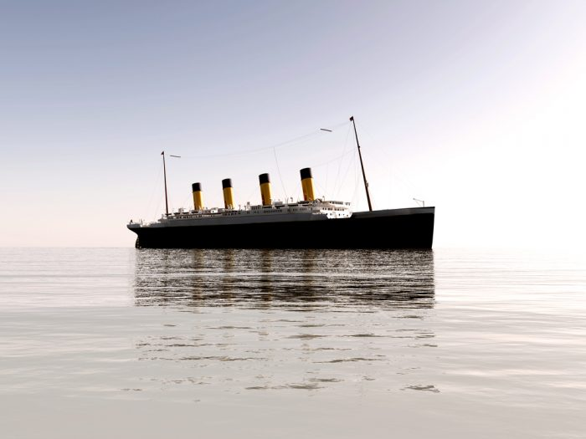 Strong Thesis Statement Example: The Titanic can teach us about the hubris of man and the dangers of classism and separatism, as it was the largest non-war disasters in history.[/caption]
Weak Examples:
The Titanic was the biggest non-war disasters in history.
The US helped enable the Holocaust.
The Vietnam War was the first TV war.
Truman’s decision to drop the H-bomb on Japan ended world war two.
The Roaring twenties were the last great period of artistic expression in America.

Hot Topics Thesis Statement Examples
Strong Examples:
-Social media is responsible for anxiety, self-esteem issues and general discontent in society.
-The bloated salaries of entertainment and sports professionals only serve to foster an imbalanced society. These salaries should be capped with such massive rewards given to those in public service.
-There is no tangible way to measure success of US involvement in Iraq. U.S presence there is nothing but a waste of resources with very little benefit to American people.
-Wiretapping of the U.S government on its citizens represents a violation of the rights to privacy and autonomy. Citizens should have the right to overthrow the members of government who engaged in such practices.
-The fashion industry has a powerful influence on society, particularly the development of young girls. Imposing a minimum weight range for models can help to ensure that impressionable young girls are not subjected to toxic body image presentations of super skinny models.
-The moderate convenience that smart phones provide pales in comparison to the negative impacts it places on a young person’s life: from the pressures of social media to a constant barrage of distractions. No child should have a smart phone until they are 18.
[caption id="attachment_4657" align="alignnone" width="700"] Strong Thesis Statement Example: Social media is responsible for anxiety, self-esteem issues and general discontent in society.[/caption]
Weak Examples:
-Social media has taken more than it has given
-Entertainment and sports professionals should received mandated salary caps.
-The Iraq war was a mistake.
-Wiretapping by the US government on its citizens should be considered tyranny.
-Fashion models should have a minimum weight range for their height.
-Parents should not allow their children to have smart phones.

Thesis Statement Examples for Opinion Essays
Strong Examples:
-In my opinion, children who grow up in big cities lead more productive lives.
-I am of the opinion that having a pet helps soothes the many stresses of life, from work to relationship challenges.
-I believe that taking regular time to experience nature is good for mental, emotional and physical health.
Weak Examples:
-In my opinion, it’s good for children to grow up in big cities.
-I am of the opinion that having a pet helps relieve stress.
-I believe it’s important to interact with nature.
[caption id="attachment_4655" align="alignnone" width="700"] Strong Thesis Statement Example: I am of the opinion that having a pet helps soothes the many stresses of life, from work to relationship challenges.[/caption]

Narrative Thesis Statement Examples
Strong Examples:
-My trip to Europe exposed me to different cultures, languages, idioms, customs and ways of life that it forever altered my perspective on the meaning of life.
-My path to college was riddled with obstacles and rather than dodging them when the opportunity presented itself, I sought to destroy them.
-Unconditional love may not be able to move mountains, but it can definitely help one realize one’s own potential
Weak Examples:
My trip to Europe was awesome.
I overcame obstacles through hard work.
I think family is the most important thing in life.

Informative Thesis Statement Examples
Strong Examples:
-1950s advertising idealizes the role of being a housewife and mother through idyllic imagery as a means of continuing the patriarchy.
-F. Scott Fitzgerald directly influenced the work of J.D. Salinger as shown in the use of repeated themes such as old New York money, boarding and prep schools, and excessive tobacco and alcohol consumption.
-Slavery in America was different than any form of slavery that preceded it and its existence is responsible for current issues in race relations.
Weak Examples:
-1950s imagery showed women as housewives and mothers.
- F. Scott Fitzgerald influenced the writer J.D. Salinger.
-Slavery in America has had a long legacy.
[caption id="attachment_4666" align="alignnone" width="700"]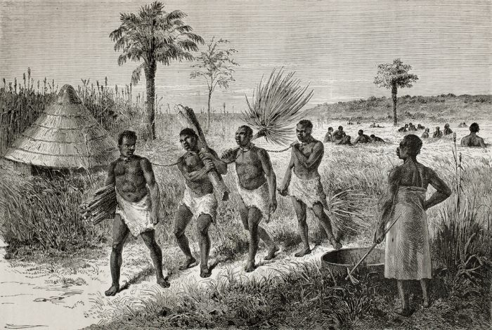 Strong Thesis Statement Example: Slavery in America was different than any form of slavery that preceded it and its existence is responsible for current issues in race relations

Conclusion
After looking over copious thesis statement examples, the difference between a subpar thesis and an excellent thesis should be apparent. The more you refine your thesis and make it as precise as possible, the more you will strengthen it. A thesis statement is more complex than a topic statement as it connects with the reasons that will ultimately support it. Examining thesis paper examples that support such theses can further offer clarification into the hazy writing process.
Without a strong thesis statement, there’s no hope in getting top marks. If you find yourself really stuck on trying to develop an adequately nuanced thesis statement, seeking out specialized assistance can help exponentially. Ordering a custom written paper to use as a guide can offer tremendous clarity into this process. This will provide you with a thesis statement template and paper so you can see exactly what an excellent thesis statement looks like for the exact subject you need it to address. You can also see the best ways it is supported through evidence, observation, research and a host of other tactics. This can not only shed light on the entire paper-writing process, but also gives you a competitive edge over other students.

